A handy starter template including Phaser, TypeScript, Rollup and Vite.
Posted on 2nd Apr 2021.

Making Your First Game in Phaser 3 with TypeScript
I recently got a chance to use Phaser 3 and TypeScript to build Root Maker with my Ludum Dare team. It worked out great. Phaser is one of the best frameworks around for HTML5 game development, and it’s definitely worth checking out if you haven’t.
I wanted to write this tutorial to help others get their Phaser 3 and TypeScript projects up and running as quickly as possible. If you’d rather just see the code, you can find a link to the repository at the end of the post.

1. Setting Up your Environment

IDE
Phaser is compatible with any editor or IDE. Visual Studio Code tends to be one of the better options because of its built-in TypeScript support, but feel free to pick your preferred environment.

Node
For this tutorial, we’ll be using Node.js with Yarn as a package manager, but this method will also work with npm. We’ll need to use Node since we’ll be developing in TypeScript, and using Yarn will help us manage and install all of the dependencies we’ll need for our game.

Setup
First, you’ll want to create a new directory for your game. Once you have a new folder, type yarn init to go through the process of creating a package.json file. This will contain all of the information about your project and its dependencies. You can answer the init questions however you want – you can edit all of your answers later.
Next, we’ll need to get all of our dependencies. We’re going to be using webpack to bundle our files and run our test server, and we’re also going to need to grab the Phaser and TypeScript modules. (I’m assuming some familiarity with the Node ecosystem here, but if all of this sounds like another language to you, keep reading; I’ll explain everything you need to do as we go).
To get all of these, run these two commands:
Bash
yarn add --dev copy-webpack-plugin ts-loader typescript webpack webpack-cli webpack-dev-server

Bash
yarn add phaser
The first command will install all of the modules we need to run and test our code locally. It will also bundle them into files we can eventually host online for people to play. All of those modules are added to our development dependencies. One important note is that we’re using webpack-dev-server to run our local server.
The second command installs Phaser as a dependency, and it’s one that we’ll need outside of just a development environment. The Phaser repository, as of version 3.17, now includes the type definitions by default. Because of that, installing Phaser via Yarn means we’ll automatically have types for Phaser.

Configuring webpack
We’ll need to tell webpack how it should compile our game. We added a few dependencies to help do this already, like the ts-loader plugin and the copy-webpack-plugin. However, webpack also requires a webpack.config.js file to understand how to compile our project.
webpack config files are almost a separate language unto themselves, and they can be pretty confusing for someone who hasn’t worked with them before. Rather than go through each line of what we need, copy the contents of this file from the starter kit I wrote into a file called webpack.config.js in your root directory.
As a brief overview, the first part of the file (from the entry to the output property) is just telling webpack where our project starts, where the compiled version should be output, and how to resolve TypeScript files. The latter part, under plugins, defines some of the webpack additions it needs in order to work with Phaser.

Configuring TypeScript
Similar to webpack, TypeScript also needs a tsconfig.json file to help the TypeScript compiler understand how to handle your project. Create a new file in your root directory with that file name, and type this:
Json
{
"compilerOptions": {
"target": "es5",
"sourceMap": true
},
"include": [
"**/*.ts"
]
}
This tells TypeScript which files it should try to compile and which version of JavaScript to shoot for.

Adding a Script to Run our Game
At this point, our project infrastructure should be pretty much set up. All we need is a way to actually run our game. Primarily, we need to tell webpack when to compile our code and host it via a local server.
To do this, add this code to your package.json file before the dependencies section:
Json
"scripts": {
"build": "webpack",
"dev": "webpack-dev-server"
},
Now all we have to do is type yarn dev, and webpack will automatically compile our code and host a server for us. You can even keep this running while you work–it will automatically rebuild whenever it detects a code change.

2. Creating Your Game
Now that our project infrastructure is all good to go, we can start actually coding. It’s definitely worth it to spend some time combing through Phaser’s documentation and examples, but I’ll give a brief overview of how Phaser works here.
At a high level, every game in Phaser has a single Game object that contains information about the game and how it should run. A Game object has a list of Scene objects that make up a game.
You can think of a scene as the thing on your screen at any given time, whether that be the main menu, a certain level, or a “Game Over” message. However, scenes are versatile. Not only can small things be their own scene, but you can have multiple scenes visible at the same time (we won’t cover that in this tutorial, though).

Creating a HTML Container
Let’s start by creating an HTML file where our game can live. Create a new file called index.html, and add this code to it:
Html
<!DOCTYPE html>
<html lang="en">
<head>
<meta charset="UTF-8">
<title>Sample Project</title>
<meta name="viewport" content="width=device-width, initial-scale=1, user-scalable=no">
<meta name="HandheldFriendly" content="True">
<meta name="MobileOptimized" content="320">
<meta http-equiv="cleartype" content="on">
<style>
html,
body,
canvas {
margin: 0 !important;
padding: 0 !important;
overflow: hidden !important;
}
</style>
</head>
<body>
<div id="content"></div>
<script src="vendors.app.bundle.js"></script>
<script src="app.bundle.js"></script>
</body>
</html>
This code creates a container div where our game will live and also adds some styling information to help format our game.
You’ll notice there are two script tags. If you go back to our webpack.config.js file, you’ll see that there is an optimization section at the bottom where we tell webpack to build our node_modules directory separate from the code that we actually write.
We do this for performance reasons. Whenever we change our code, webpack will recognize that it doesn’t have to re-bundle all of our dependencies. This becomes especially useful as you add more dependencies to a project later on.

Creating our Game Object
Now it’s time to actually write some code. Create a new directory in your project called src, and create a file in that directory called main.ts. This is where we’ll define our Game object.
Add this code to the file:
TypeScript
import * as Phaser from 'phaser';

const gameConfig: Phaser.Types.Core.GameConfig = {
title: 'Sample',

type: Phaser.AUTO,

scale: {
width: window.innerWidth,
height: window.innerHeight,
},

physics: {
default: 'arcade',
arcade: {
debug: true,
},
},

parent: 'game',
backgroundColor: '#000000',
};

export const game = new Phaser.Game(gameConfig);
In this code, we’re creating a configuration object, and then passing that in to the constructor for Phaser.Game (the aforementioned Game object). This creates a game that’s the same size as the window where you run it. If you run your game now by typing yarn dev into your terminal and then going to localhost:8080 in your browser, you should see a black screen. While it isn’t very appealing, it does mean that your game is running!

3. Your First Scene
A Game object may be the thing that keeps track of everything going on with your game, but individual Scene objects are what make your game actually feel like a game.
So, we need to create a scene. In your main.ts file, add this code above your gameConfig (but below where you import Phaser):
TypeScript
const sceneConfig: Phaser.Types.Scenes.SettingsConfig = {
active: false,
visible: false,
key: 'Game',
};

export class GameScene extends Phaser.Scene {
private square: Phaser.GameObjects.Rectangle & { body: Phaser.Physics.Arcade.Body };

constructor() {
super(sceneConfig);
}

public create() {
this.square = this.add.rectangle(400, 400, 100, 100, 0xFFFFFF) as any;
this.physics.add.existing(this.square);
}

public update() {
// TODO
}
}
Once we’ve defined a new scene, we need to tell our Game object about it. A Game object has a property called scene that can take in either a single scene or a list of scenes. For now, we only have one scene, so add this line inside of your gameConfig object:
TypeScript
// ... gameConfig {
scene: GameScene,
// ... }
All of a sudden, our game is a bit more exciting. If you run this now, you should see a white square appear on your screen. In the code above, we’re defining a scene, then telling it to create a white square at 400, 400 with a width and height of 100 pixels. The create method is called automatically by scenes whenever they are started, and it the best place to create any game objects the scene needs.
Another important method is the update method, which gets called each tick and should be used to update the state of the scene or its game objects. We’ll get to that method in the next section.
You’ll also notice in the code above that we create a field for the square on our GameScene. We can reference this later when we add input controls. In Phaser, you can add physics-enabled game objects by calling this.physics.add rather than this.add. Unfortunately, at the time of writing this tutorial, there is no built-in physics rectangle factory, so we first have to create the rectangle and then add a physics body after by calling this.physics.add.existing on the square.

4. Adding Movement
We have a game, a scene, and a square. All that we need now is a way for the player to provide input to the game. To do this, we’re going to change the update method of our GameScene class. Replace the // TODO with the following code:
TypeScript
const cursorKeys = this.input.keyboard.createCursorKeys();

if (cursorKeys.up.isDown) {
this.square.body.setVelocityY(-500);
} else if (cursorKeys.down.isDown) {
this.square.body.setVelocityY(500);
} else {
this.square.body.setVelocityY(0);
}

if (cursorKeys.right.isDown) {
this.square.body.setVelocityX(500);
} else if (cursorKeys.left.isDown) {
this.square.body.setVelocityX(-500);
} else {
this.square.body.setVelocityX(0);
}
If you run your game now, the square should move in different directions as you press down on the arrow keys. This code uses Phaser’s built-in Arcade physics system to set the velocity of our square. We’re missing some things, like checking to make sure our square stays within our screen boundaries or adding other objects to collide with, but this simple code should get you started on implementing the actual mechanics of your game.

Conclusion
This tutorial was meant to be a brief overview of how to start developing in Phaser 3 with TypeScript. You can go to the GitHub repository for the starter kit I wrote to download the source code for this tutorial. It contains everything we covered, as well as some other useful tips about switching between scenes and menu buttons. Additionally, you can use it as a guide for how you might want to organize your project as you start adding more files.
I hope this tutorial was helpful and that you’ll feel like a Phaser pro in no time. Be on the lookout for more tutorials coming soon about more advanced topics with Phaser!

Easily Use Typescript with Phaser 3

Write game code that scales.
by Tommy Leung on 5 minute read

JavaScript is great for creating small games but have you ever gone back to an old JavaScript project and had no idea what properties exist on an object or what should be passed to a function?
The only way to figure out what's going on is to console.dir objects or use the debugger. And even then you won't easily figure out what properties are optional or required at a later point.
The odds of introducing a null reference exception or other bug is very high in this state.
There are a few ways to solve this problem:
- use JSDoc to annotate your objects and functions
- use a type checker like Flow
- use TypeScript: a typed superset of JavaScript
All three options are good and in this article, we are going to look at using TypeScript to make your game code more scalable and maintainable.
Note: you can uses tests to mitigate some of the potential issues as well but it won't catch them while you are writing the code.

Simplicity with Parcel
There are many ways to set up a Phaser 3 project with TypeScript depending on what bundler you use or if you decide to hand-roll your setup.
We recommend using Parcel and the phaser3-parcel-template.
Check out our guide to using the template here if you need detailed instructions. Otherwise clone the template to follow along:
git clone https://github.com/ourcade/phaser3-parcel-template.git my-folder-name

cd my-folder-name

npm install

Add a tsconfig
This step is not strictly necessary but it is recommended to support absolute paths, change TypeScript compiler settings, or configure your code editor. Here's a recommended tsconfig.json file. Create it in the project root.
1  2  3  4  5  6  7  8  9  10  11  12  13  14  15  16  17  18  19  20  21  22  23  24  25  26  27  28  29 | {  "compilerOptions": {  "target": "esnext",  "module": "esnext",  "strict": true,  "noImplicitAny": false,  "noEmit": true,  "allowJs": true,  "jsx": "preserve",  "importHelpers": true,  "moduleResolution": "node",  "experimentalDecorators": true,  "esModuleInterop": true,  "allowSyntheticDefaultImports": true,  "sourceMap": true,  "baseUrl": "./src",  "paths": {  "~/*": ["./*"]  },  "typeRoots": [  "node_modules/@types",  "node_module/phaser/types"  ],  "types": [  "Phaser"  ]  },  "include": ["src/**/*"]  }
Learn more about <code>tsconfig</code> options here.

Using TypeScript
There is no other set up steps thanks to Parcel! 🎉
The only thing you need to do is change the .js files to .ts and start writing TypeScript.
Here's what we did to main.ts as an example:
1  2  3  4  5  6  7  8  9  10  11  12  13  14  15  16  17  18 | import Phaser from 'phaser'  import HelloWorldScene from '~/scenes/HelloWorldScene'  const config: Phaser.Types.Core.GameConfig = {  type: Phaser.AUTO,  width: 800,  height: 600,  physics: {  default: 'arcade',  arcade: {  gravity: { y: 200 }  }  },  scene: [HelloWorldScene]  }  export default new Phaser.Game(config)
Notice that we are giving config a type of Phaser.Types.Core.GameConfig on line 5. Now you'll get property suggestions with a code editor like VS Code.

Bouncing Phaser Logo
We will move the basic bouncing Phaser logo logic into a class to demonstrate some more TypeScript features!
1  2  3  4  5  6  7  8  9  10  11  12  13  14  15  16  17  18  19  20  21  22  23  24  25 | import Phaser from 'phaser'  export default class BouncingLogo  {  private image: Phaser.Physics.Arcade.Image  get display()  {  return this.image  }  constructor(scene: Phaser.Scene, x: number, y: number, texture: string)  {  this.image = scene.physics.add.image(x, y, texture)  this.initialize()  }  private initialize()  {  this.image.setVelocity(100, 200)  this.image.setBounce(1, 1)  this.image.setCollideWorldBounds(true)  }  }
Here we have a wrapper class that creates the physics image and sets the physics properties in initialize(). We are using the private modifier on a class property and a class method.
We are also specifying type in the constructor arguments. Now you'll always know that texture is a string and not something else like a Texture instance.

Putting it Together
To put it all together we will convert the HelloWorldScene to use TypeScript features and the BouncingLogo we created.
1  2  3  4  5  6  7  8  9  10  11  12  13  14  15  16  17  18  19  20  21  22  23  24  25  26  27  28  29  30  31  32  33  34  35  36  37  38  39  40  41  42  43  44  45  46  47  48  49 | import Phaser from 'phaser'  import BouncingLogo from './BouncingLogo'  enum ImageNames  {  Sky = 'sky',  Logo = 'logo',  RedParticle = 'red_particle'  }  export default class HelloWorldScene extends Phaser.Scene  {  constructor()  {  super('hello-world')  }  preload()  {  this.load.setBaseURL('http://labs.phaser.io')  this.load.image(ImageNames.Sky, 'assets/skies/space3.png')  this.load.image(ImageNames.Logo, 'assets/sprites/phaser3-logo.png')  this.load.image(ImageNames.RedParticle, 'assets/particles/red.png')  }  create()  {  this.add.image(400, 300, ImageNames.Sky)  const emitter = this.createEmitter(ImageNames.RedParticle)  const logo = new BouncingLogo(this, 400, 100, ImageNames.Logo)  emitter.startFollow(logo.display)  }  private createEmitter(textureName: string)  {  const particles = this.add.particles(textureName)  const emitter = particles.createEmitter({  speed: 100,  scale: { start: 1, end: 0 },  blendMode: 'ADD'  })  return emitter  }  }
TypeScript supports enums and we create one on line 4 in place of constant variables for unique image names. In modern JavaScript you would use something like: const ImageNameSky = 'sky'.
Then we create our BouncingLogo on line 32 using the ImageNames.Logo enum.
Last thing of note is the private createEmitter(textureName: string) method that has the private access modifier and a typed textureName parameter.
You can test all this out if you haven't already by going into your project folder and using:
npm run start
Open http://localhost:8000 in your browser and the familiar Phaser logo will be bouncing around. 🎉

Next Steps
Using TypeScript with Phaser 3 is a piece of cake when you use Parcel and the phaser3-parcel-template.
You can use all TypeScript features from decorators to generics. Learn more about TypeScript here.
Let us know in the comments below if anything doesn’t work or is unclear. We’ll be happy to fix or clarify!
Be sure to sign up for our newsletter so you don't miss any future Phaser 3 game development tips and techniques!
https://blog.ourcade.co/posts/2020/phaser-3-typescript/

https://spin.atomicobject.com/2019/07/13/phaser-3-typescript-tutorial/

Working with Phaser, TypeScript and webpack – step 1
- HTML5
- Javascript
- Phaser
- TypeScript
Emanuele Feronato on August 3, 2021
It is no mystery that one of the biggest difficulties in starting to build Phaser games is the need to install web servers, bundlers, packers, compilers and so on.
A lot of new developers ask me all the time why should they install all this stuff just to run web pages with some JavaScript in it.
There would be a lot of tech-based answers to give, but the best, shortest and simplest that comes to mind is: because the world is moving in this direction.
So, I’m not going to try to convince you to change your way of programming, but rather I’m going to show you that it’s really easy to take this little step.
So easy, that you will continue programming the way you are used to without even noticing the difference, after a little setup.
If you are completely new to concepts like Node.js, npm and Visual Studio Code, I suggest you to have a look at Phaser and the migration from JavaScript to TypeScript step 1, 2, 3 and 4.
In these examples I am using Parcel rather then webpack, but reading the posts will give you the information required to install Node.js and npm.
Create a new empty folder, in my example i called it phaserwebpack, launch Visual Studio Code, click “Open Folder” then select the folder you just created:

If you are asked to trust the authors, do it. All in all, it’s you!

Open a new Terminal window. We are going to use it quite a lot

Let’s start with the creation of a new project with:
npm init -y

This will create a package.json file whose automatic generated content is ok at the moment.
Then, let’s install the latest Phaser version:
npm install --save phaser

Great! You will notice some lines have been added to package.json file.
Finally it’s time to install webpack:
npm install --save-dev webpack

We also need to install an extension to make webpack run from command line interface:
npm install --save-dev webpack-cli

Now, we have to install two plugins to copy files and clear folders. We’ll need them when it’s time to build distribution bundles:
npm install --save-dev copy-webpack-plugin

and
npm install --save-dev clean-webpack-plugin

Last but not least, we need a web server to test our scripts, so let’s install it:
npm install --save-dev webpack-dev-server

Now your package.json file should look like this one:
1  2  3  4  5  6  7  8  9  10  11  12  13  14  15  16  17  18  19  20  21  22 | {  "name": "phaserwebpack",  "version": "1.0.0",  "description": "",  "main": "index.js",  "scripts": {  "test": "echo \"Error: no test specified\" && exit 1"  },  "keywords": [],  "author": "",  "license": "ISC",  "dependencies": {  "phaser": "^3.55.2"  },  "devDependencies": {  "clean-webpack-plugin": "^4.0.0-alpha.0",  "copy-webpack-plugin": "^9.0.1",  "webpack": "^5.48.0",  "webpack-cli": "^4.7.2",  "webpack-dev-server": "^3.11.2"  }  }

You probably noticed all stuff you installed using --save-dev, like Phaser, us under “dependencies”, while the stuff installed using --save is under “devDependencies”.
What’s the difference? Under “dependencies” we find the libraries which needs to be included in the final distributable bundle. In this case, a Phaser game obviously requires Phaser.
Under “devDependencies” we find the libraries we use during development, like the web server, webpack and its plugins, but which we don’t need once we need to publish the final bundle.
What to do with webpack? We need to create two configuration files, one for development and one for distribution.
I called my development configuration file webpack.development.js:
1  2  3  4  5  6  7  8  9  10  11  12  13  14  15  16  17  18  19  20  21  22  23  24  25  26  27  28 | const path = require('path');  module.exports = {  entry: {  // this is our entry point, the main JavaScript file  app: './src/main.js',  },  output: {  // this is our output file, the one which bundles all libraries  filename: 'main.js',  // and this is the path of the output bundle, "dist" folder  path: path.resolve(__dirname, 'dist'),  },  // we are in development mode  mode: 'development',  // we need a source map  devtool: 'inline-source-map',  // development server root is "src" folder  devServer: {  contentBase: './src'  }  };

Ok, now we have a development configuration, so let’s start developing something.
This simple official example is good to build with webpack, as it also features an image.
At line 7 of webpack.development.js we decided the entry point is ./src/main.js, so let’s create a src folder with these files:
index.html, the classic HTML page which can host a Phaser game:
1  2  3  4  5  6  7  8  9 | <!DOCTYPE html>  <html>  <head>  <script src="main.js"></script>  </head>  <body>  <div id="thegame"></div>  </body>  </html>

Look at line 4 how we include main.js which is the entry point, and at line 7 with the thegame element where we want our Phaser game to run in.
Now, let’s write main.js:
1  2  3  4  5  6  7  8  9  10  11  12  13  14  15  16  17  18  19  20  21  22  23  24  25 | import 'phaser';  class PlayGame extends Phaser.Scene {  constructor() {  super("PlayGame");  }  preload() {  this.load.image('logo', 'assets/phaser3-logo.png');  }  create() {  this.image = this.add.image(400, 300, 'logo');  }  update() {  this.image.rotation += 0.01;  }  }  let config = {  width: 800,  height: 600,  parent: 'thegame',  scene: PlayGame  };  new Phaser.Game(config);

There isn’t that much to say here, it’s just the official example rewritten.
And obviously we need to add the phaser3-logo.png image to assets folder.
Now, let’s change a bit package.json by removing the test script and adding our own:
1  2  3  4  5  6  7  8  9  10  11  12  13  14  15  16  17  18  19  20  21  22 | {  "name": "phaserwebpack",  "version": "1.0.0",  "description": "",  "main": "index.js",  "scripts": {  "development": "webpack serve --open --config webpack.development.js"  },  "keywords": [],  "author": "",  "license": "ISC",  "dependencies": {  "phaser": "^3.55.2"  },  "devDependencies": {  "clean-webpack-plugin": "^4.0.0-alpha.0",  "copy-webpack-plugin": "^9.0.1",  "webpack": "^5.48.0",  "webpack-cli": "^4.7.2",  "webpack-dev-server": "^3.11.2"  }  }

And now in the console just write:
npm run development

A new browser window should open, with the Phaser example running in it:

If you change something in your main.js file, such as the rotation speed, and save, the webpage will reload automatically and show the updated result.
It was easy, wasn’t it? During next step, out this week, we’ll see how to bundle and distribute your games, and finally in the third step how to work with TypeScript.

Phaser and the migration from JavaScript to TypeScript – Step 2 – npm and Parcel
- HTML5
- Javascript
- Phaser
- TypeScript
Emanuele Feronato on May 25, 2021
With Phaser4 version to be released hopefully not that late, it’s recommended to start coding in TypeScript, but before even thinking about TypeScript, in previous post we saw how to install Node.js and npm, then how to start a local server to serve a Phaser game.
Now it’s time to start using npm and Parcel to download Phaser and build a game on the fly, from command line. Still nothing about TypeScript today, but a lot of new stuff to see.
Let’s create a Phaser project with npm.
Create an empty folder, open your shell and write:
npm init -y

A new project will be created, prompting something like this:
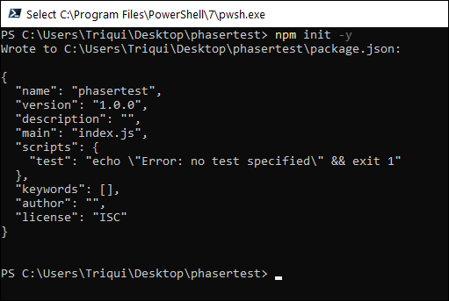
As the output says, a new file called package.json has been created in your folder, and its content is:
1  2  3  4  5  6  7  8  9  10  11  12 | {  "name": "phasertest",  "version": "1.0.0",  "description": "",  "main": "index.js",  "scripts": {  "test": "echo \"Error: no test specified\" && exit 1"  },  "keywords": [],  "author": "",  "license": "ISC"  }

Now let’s install Phaser directly from the official source repository, with
npm install phaser --save

No more files to manually download, npm will manage everything for you, and after a few seconds you should have Phaser intalled in your project:
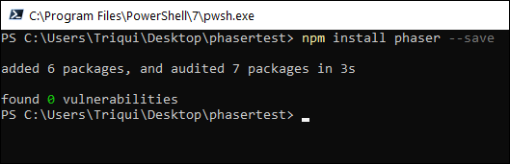
Content of package.json also changed, this way:
1  2  3  4  5  6  7  8  9  10  11  12  13  14  15 | {  "name": "phasertest",  "version": "1.0.0",  "description": "",  "main": "index.js",  "scripts": {  "test": "echo \"Error: no test specified\" && exit 1"  },  "keywords": [],  "author": "",  "license": "ISC",  "dependencies": {  "phaser": "^3.54.0"  }  }

Where did npm install Phaser? Somewhere inside node_modules folder. Actually, it’s not important where Phaser has been installed, because npm will handle everything for us.
How did npm know the latest Phaser version is 3.54 (at the time of writing)?
It does not matter, but by installing Phaser this way we’ll always get the latest version.
Now let’s install Parcel, the tool we are using to bundle and create distributable versions of our project, with
npm install parcel-bundler -g

Another few seconds to wait, then you’ll have Parcel installed:

In some cases, you may get a lot of errors, and have Parcel failing to install: it’s probably because you don’t have Python installed on your computer.
In this case simply go to https://www.python.org/downloads/ and download the latest version:

Then try to install Parcel again and everything should work.
Finally we can start creating our game. Create a folder called game, with three files in it: index.html, game.js and gameScene.js.
This is the content of index.html:
1  2  3  4  5  6 | <!DOCTYPE html>  <html>  <head>  <script src="game.js"></script>  </head>  </html>

I am sure you noticed I am not calling Phaser.
Look at game.js:
1  2  3  4  5  6  7  8  9  10  11 | import Phaser from 'phaser'  import { GameScene } from "./gameScene";  const config = {  type: Phaser.AUTO,  width: 640,  height: 320,  scene: GameScene  };  new Phaser.Game(config);

It’s just a basic Phaser game initialization, and the “game” itself comes in GameScene Scene which is declared in gameScene.js:
1  2  3  4  5  6  7  8  9 | export class GameScene extends Phaser.Scene {  constructor() {  super({ key: "GameScene" });  }  create() {  this.add.text(10, 10, "HELLO WORLD");  }  }

What a nice Hello World script! Now how do we run it? We didn’t even linked Phaser in any way.
Let’s start the game from the shell:
parcel ./game/index.html

After a few seconds, a web server is created and Phaser game is launched:
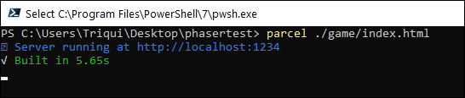
Open http://localhost:1234 on your browser, and here is the game.
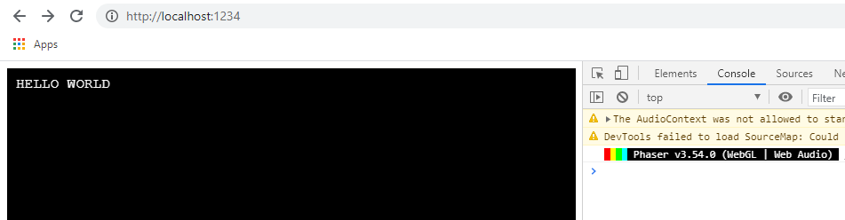
Change gameScene.js this way:
1  2  3  4  5  6  7  8  9 | export class GameScene extends Phaser.Scene {  constructor() {  super({ key: "GameScene" });  }  create() {  this.add.text(10, 10, "HELLO WORLD, WHAT A WONDERFUL WORLD!");  }  }

Just save it, don’t do anything else and look at the web page at http://localhost:1234:
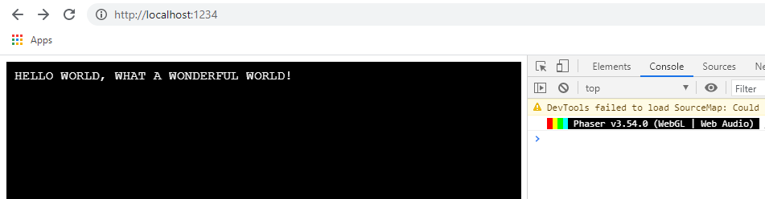
When you update a file, the page is refreshed with your latest changes. How convenient!
Now the point is: where is my Phaser project? It’s in dist folder, look:
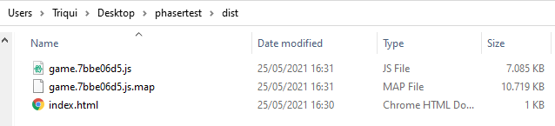
Parcel built a bundle with our JavaScript files, added Phaser and here is the final project. The names of your files may change, but this is the concept.
We are talking about 7MB for the JavaScript and more than 10MB for a map file which we do not even need to distribute the project.
When we want to distribute the project, we have to run another command, let’s say we want to save the output in a folder called finalfolder:
parcel build ./game/index.html --no-source-maps --out-dir finalfolder

And this is the output:
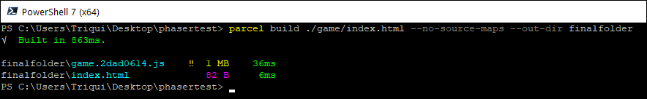
Inside finalfolder we’ll find our project ready to be distributed. 1MB of JavaScript file, which is fair, considered there’s both Phaser and the game in it.
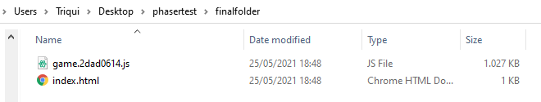
And we built and packed a Phaser project using npm and Parcel. Next step, later this week, finally… TYPESCRIPT! Stay tuned.

Phaser and the migration from JavaScript to TypeScript – Step 3 – TypeScript
- HTML5
- Javascript
- Phaser
- TypeScript
Emanuele Feronato on June 1, 2021
As promised, here we are with step 3 of the migration from JavaScript to TypeScript in the building of HTML5 games using Phaser.
In step 1 we installed and set up Node.js.
In step 2 I covered npm and Parcel.
Now it’s time to start coding in TypeScript.
First we have to install TypeScript with npm, with
npm install typescript -g

And now you have TypeScript installed.
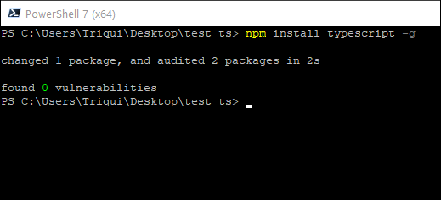
What now? Let’s create a TypeScript file called script.ts with this content:
1  2 | s = 'Hello World';  console.log(s);

Then let’s run it with
1 | tsc script.ts

And you will get errors:
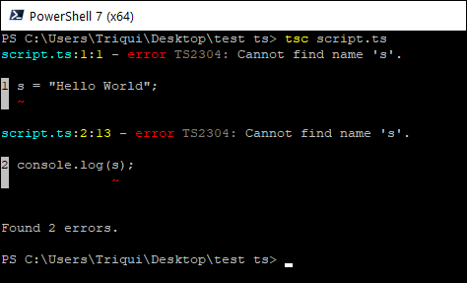
A valid JavaScript file, but it doesn’t work in TypeScript because variables must be declared, this way:
1  2 | const s = 'Hello World';  console.log(s);

or even better, this way:
1  2 | const s: string = 'Hello World';  console.log(s);

With type declaration.
Now run again
tsc script.ts

Then
npm script.js

And this time you’ll get a result:
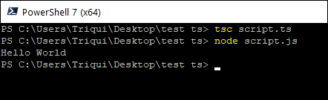
This is because TypeScript created a valid JavaScript file which has been executed by Node.js. Look at the generated JavaScript file:
1  2 | var s = 'Hello World';  console.log(s);

So, from now on, we can say we will be coding in a “cool” JavaScript, which will be translated in a “ugly” JavaScript and executed.
Time to put all together, let’s create a project as seen in Phaser and the migration from JavaScript to TypeScript – Step 2 – npm and Parcel with
npm init -y

As you should know, a file called package.json is created:
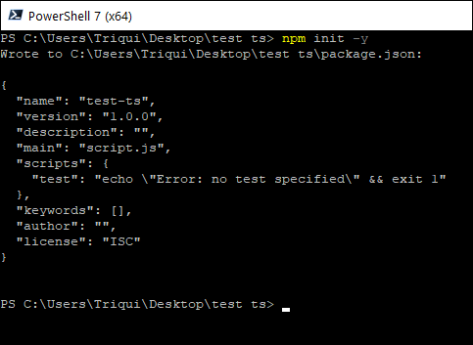
Let’s edit it, adding one line:
1  2  3  4  5  6  7  8  9  10  11  12  13 | {  "name": "test-ts",  "version": "1.0.0",  "description": "",  "main": "script.js",  "scripts": {  "test": "echo \"Error: no test specified\" && exit 1",  "parceltest": "parcel index.html"  },  "keywords": [],  "author": "",  "license": "ISC"  }

Now let’s create index.html:
1  2  3  4  5  6  7  8  9 | <html>  <head>  <title>Hello World</title>  </head>  <body>  <div id = "main"></div>  <script src = "script.ts"></script>  </body>  </html>

Then change script.ts this way:
1  2 | const s: string = "Hello World";  document.querySelector("#main").innerHTML = s;

Now if we go to command line and write
npm run test

We’ll run the “test” script inside package.json:
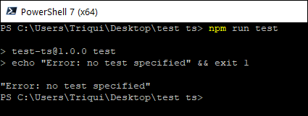
So if you call “parceltest” script…
npm run parceltest

It will run Parcel on index.html files, analyse and convert all TypeScript files and run the server as we saw in previous step:
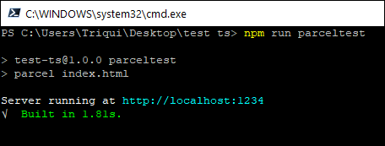
And if we go to http://localhost:1234/, we’ll see the project running:
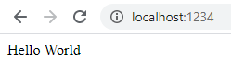
Our script.ts has also been changed:
1  2  3  4  5  6  7  8  9  10  11  12  13  14  15  16 | {  "name": "test-ts",  "version": "1.0.0",  "description": "",  "main": "script.js",  "scripts": {  "test": "echo \"Error: no test specified\" && exit 1",  "parceltest": "parcel index.html"  },  "keywords": [],  "author": "",  "license": "ISC",  "devDependencies": {  "typescript": "^4.3.2"  }  }

Now let’s intall Phaser:
1 | npm install phaser --save

And now Phaser is installed:
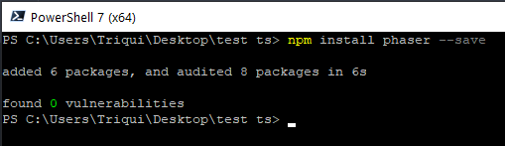
package.json changed again:
1  2  3  4  5  6  7  8  9  10  11  12  13  14  15  16  17  18  19 | {  "name": "test-ts",  "version": "1.0.0",  "description": "",  "main": "script.js",  "scripts": {  "test": "echo \"Error: no test specified\" && exit 1",  "parceltest": "parcel index.html"  },  "keywords": [],  "author": "",  "license": "ISC",  "devDependencies": {  "typescript": "^4.3.2"  },  "dependencies": {  "phaser": "^3.55.2"  }  }

Now change the content of index.html just like in previous example, but remember to use ts rather than js:
1  2  3  4  5  6 | <!DOCTYPE html>  <html>  <head>  <script src="game.ts"></script>  </head>  </html>

This is game.ts:
1  2  3  4  5  6  7  8  9  10  11 | import Phaser from 'phaser'  import { GameScene } from "./gameScene";  const config: Phaser.Types.Core.GameConfig = {  type: Phaser.AUTO,  width: 640,  height: 320,  scene: GameScene  };  new Phaser.Game(config);

And this is gameScene.ts:
1  2  3  4  5  6  7  8  9 | export class GameScene extends Phaser.Scene {  constructor() {  super({ key: "GameScene" });  }  create() {  this.add.text(10, 10, "HELLO WORLD");  }  }

Build the project again with
npm run parceltest

And here is our Phaser project up and running at http://localhost:1234/:
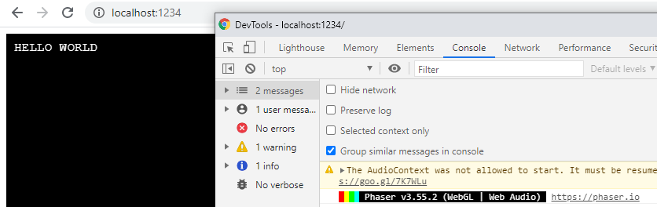
Finally we are able to code a Phaser project with TypeScript, but there is still something to see about the IDE to use and the way to define types, see you next time with the fourth and last part.

Phaser and the migration from JavaScript to TypeScript – Step 4 – installing Visual Studio Code and putting all together
- HTML5
- Javascript
- Phaser
- TypeScript
Emanuele Feronato on June 9, 2021
Welcome to the final step of the series about the migration from JavaScript to TypeScript in HTML5 game development using Phaser.
A small recap:
In step 1 we installed and set up Node.js.
In step 2 we covered npm and Parcel.
In step 3 we wrote and ran our first TypeScript Phaser project.
Now it’s time to put all together, and choose an IDE which supports TypeScript and makes our tasks easier.
Visual Studio Code is a free editor available for Windows, macOS and Linux, let’s install it:

This Visual Studio Code as soon as you open it. Let’s select “Open Folder…”

I created an empty folder in my desktop called phaserts, and selected it.
Now, from “View” menu, open “Terminal” to have your shell directly opened in Visual Studio Code.

This is how Visual Studio Code should look now:

We are now ready to start our project. Just like in step 3, execute in your shell:
npm init -y

then
npm install phaser --save

And this is what you should get:

Now, left mouse button in “Explorer” panel and let’s create a new folder:

I called the new folder game, and added the file index.html, with this content:
1  2  3  4  5  6  7  8  9 | <html>  <head>  <title>Hello World</title>  </head>  <body>  <div id = "main"></div>  <script src = "scripts/main.ts"></script>  </body>  </html>

Then, created a subfolder called scripts, and added main.ts:
1  2  3  4  5  6  7  8  9  10  11 | import Phaser from 'phaser'  import { GameScene } from "./gameScene";  const config: Phaser.Types.Core.GameConfig = {  type: Phaser.AUTO,  width: 640,  height: 320,  scene: GameScene  };  new Phaser.Game(config);

It’s important to see how Visual Studio Code helps us both with code completion:
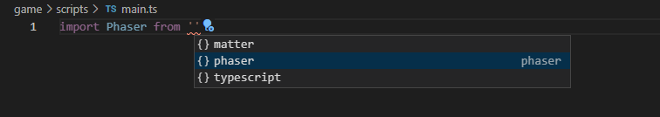
And with inline help:
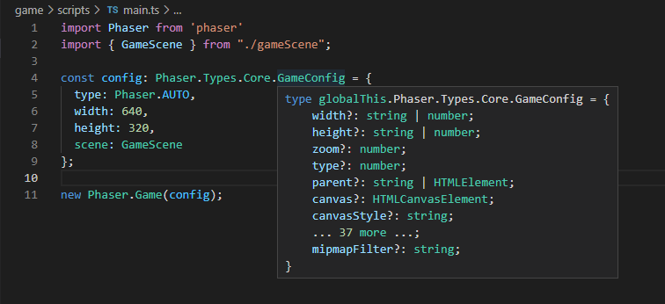
This is thanks to Phaser TypeScript definitions which are automatically loaded in the project. This will make you save a lot of time you would spend browsing the various API docs.
Let’s create gameScene.ts:
1  2  3  4  5  6  7  8  9  10  11 | export class GameScene extends Phaser.Scene {  constructor() {  super({  key: "GameScene"  });  }  create() {  this.add.text(10, 10, "HELLO WORLD FROM VISUAL STUDIO CODE");  }  }

Now let’s edit package.json and add a couple of lines:
1  2  3  4  5  6  7  8  9  10  11  12  13  14  15  16  17 | {  "name": "phaserts",  "version": "1.0.0",  "description": "",  "main": "index.js",  "scripts": {  "test": "echo \"Error: no test specified\" && exit 1",  "parceltest": "parcel ./game/index.html",  "parcelbuild": "parcel build ./game/index.html --out-dir build --no-source-maps --public-url ./"  },  "keywords": [],  "author": "",  "license": "ISC",  "dependencies": {  "phaser": "^3.55.2"  }  }

Line 8 is the “parceltest” script we already encountered in step 3 which tests the game on a local server, while “parcelbuild” at line 9 means “build a distributable version of game/index.html in build output directory, don’t create map files and set the public url to current path”.
Now we can write in the shell
npm run parceltest

to run “parcetest” script and test the project, in my case pointing the browser at http://localhost:1234:
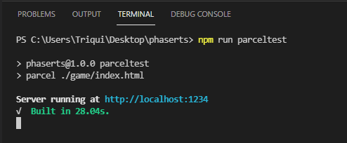
To create a distributable package, you’ll use
npm run parcelbuild

And you will find the files in build folder:
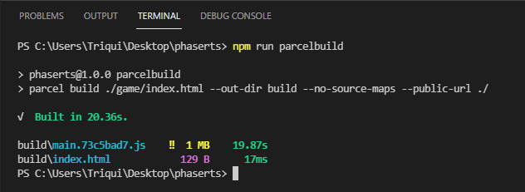
You can then distribute the content of build folder:
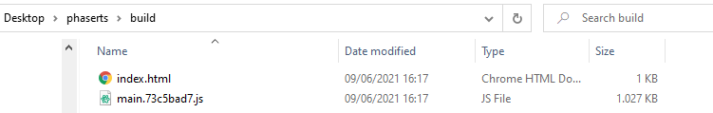
And this is the result:
Now, you have to know Parcel does not support TypeScript’s type checking. This is not a big issue, as most of TypeScript features are supported at IDE level, but just in case you want to be sure you wrote a good and clean TypeScript code, you can init TypeScript by writing in your terminal:
tsc --init

A huge tsconfig.json file will be created, but it’s not important.
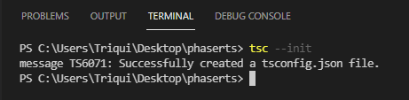
From now on, by writing on the terminal:
tsc --noEmit

You will get absolutely nothing if your TypeScript files are ok, or a list of errors like in this case where I added a “x” to a variable type:
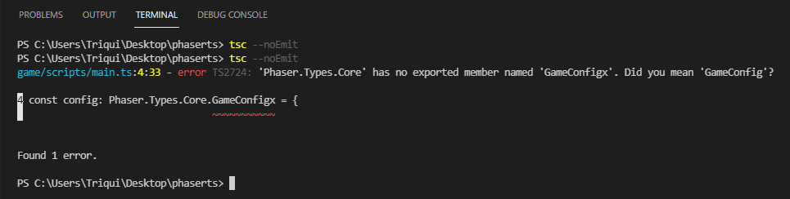
You can automate the process by changing “parcelbuild” script in package.json:
1  2  3  4  5  6  7  8  9  10  11  12  13  14  15  16  17 | {  "name": "phaserts",  "version": "1.0.0",  "description": "",  "main": "index.js",  "scripts": {  "test": "echo \"Error: no test specified\" && exit 1",  "parceltest": "parcel ./game/index.html",  "parcelbuild": "tsc --noEmit && parcel build ./game/index.html --out-dir build --no-source-maps --public-url ./"  },  "keywords": [],  "author": "",  "license": "ISC",  "dependencies": {  "phaser": "^3.55.2"  }  }

And now the mingration from JavaScript to TypeScript is over.
Finally, it’s time to start building games again, from now on in TypeScript!!
https://www.emanueleferonato.com/2021/06/09/phaser-and-the-migration-from-javascript-to-typescript-step-4-installing-visual-studio-code-and-putting-all-together/

Setting up TypeScript, Phaser, Webpack, … Argh!

Write a game that runs in the browser using TypeScript and Phaser 3
You want to write a game that runs in a browser. You decide on TypeScript, and Phaser 3. Your code will be modular, broken into many files, with well-defined links between them. For production, you’ll pack your JS into one file, and minify it.
Your IDE will be VS Code. You’ll tell VS Code about Phaser’s symbol definitions, so IntelliSense can help you. You’ll use a linter. There’ll be a GitHub repo for your project.
To the keyboard! The Interweb tells you to install an endless stream of dev tools. You copy and paste an import statement into your TypeScript, but it’s red and squiggly. Oh, but that statement isn’t in other examples. Should you remove it? The build tools complain about something, but you don’t know what. Argh!
I feel your pain. Trying to copy and paste my way into a good dev environment didn’t work. I had to step away from the keyboard, understand what the dev tools do, how they’re configured, and how they relate to each other.
This article explains what I’ve learned so far. Maybe it will help you, too.
It explains what I think is happening, anyway. I’m still shaky on the deets. If there are errors, or ways to improve, please comment.
Most writers start by telling you how to install the dev tools. That comes last in this article. The idea is to build a mental model of the dev tools and procedures first. Then, once we know what we’re trying to do, we’ll set it up.
Let’s start by setting some goals. Then we’ll look at ways of getting there.

Goals
There are goals for:
- Project organization
- Build process
- Development environment

Goals for project organization
Modularity helps people think about complex things. We’ll break the code up into many files, so we can work on the pieces individually. Some pieces will be Phaser abstractions, like scenes. Other pieces will be our own abstractions, like game state.
We’ll put our app’s files into a folder, to keep them together. We’ll put related pieces into their own subfolders. We’ll also have a subfolder for libraries like phaser.min.js, a subfolder for image assets, etc.
The build process and dev environment should adapt to the way we want to organize our project. No matter how we organize the subfolders, the tools should still work.
One of our JS files will be the app’s entry point. It’s the code that starts everything running. We’ll name the file app.ts, though you can call it whatever you like.

Goals for the build process
Browsers don’t understand TypeScript. We’ll have to convert our TypeScript code into JavaScript. Which JS version? We’ll target ES5, since every browser (more or less) understands it. The TypeScript compiler, TSC, will do the translation. TSC is a program that translates a TypeScript file into a JavaScript file. TypeScript in, JavaScript out.

Modularity
Recall that we’ll achieve modularity by splitting the code up into files. The program will be easier to think about if we limit how much code chunks know about each other.
You can use TypeScript’s export and import statements to link code chunks. For example, the code to model a dog might be in dog.ts:
Say the code in playscene.ts uses the dog code:
import { Dog } from "./dog";
let oscar: Dog = new Dog();
console.log(oscar.bark());
Someone can write playscene.ts without knowing how dogs bark. All they need to know is that there is a Dog class, that has a bark() method. They import Dog from dog.ts, and off they go.
Recall that TSC converts TypeScript into JS. TypeScript in, JS out. Most of the time, TSC can do its job without help. For example, it can convert let x: string; to var x;.
import and export are more difficult for TSC. There are no easy substitutes in ES5. People created various ways of adding modularization to ES5. They created standards like CommonJS, AMD, and others. Jurgen Van de Moere wrote an introduction — Thanks, Jurgen.
Suppose we pick CommonJS, since it’s… er, common. Two things have to happen. First, a JS file with the code for the CommonJS library has to be added to our codebase. Maybe we use the file common.js from the Interwebs. Second, TSC has to know that it should use the CommonJS API to do the equivalent of export and import. Later, we’ll see how we tell TSC that it should use the CommonJS API.

Packing
We have a bunch of TypeScript files we wrote. TSC will convert each one into JavaScript, so now we have a bunch of JavaScript files. We’ll smoosh the JavaScript files together into one file, for users’ browsers to download. That smooshed file is the distributable. Let’s call it bundle.js. You can call yours anything you want.
How to use the distributable? Here’s what the HTML for your game might look like:

Minifying
Once we’ve smooshed everything, we’ll want to minify bundle.js. That means to make it smaller, by removing spaces, using shorter variable names, and applying other tricks. For example, suppose we had this JavaScript:
var dogSize = "big";
if (dogSize === "big") {
console.log("A big dog!");
}
This is equivalent:
var d="big";if(d==="big"){console.log("A big dog!")}
It does the same thing, but would be a smaller download.
There’s a difference between a distributable you use for production (that is, send to users), and one you use for development (for testing and debugging). The production distributable should be minified, to reduce users’ download time. However, in development, minification is less of an issue.
It would be nice if our build process could run in either production mode (minifying), or development mode (no minifying).

Build process goals summary
We want to put all of our TypeScript files in one end. Get one ES5 file (bundle.js) out of the other end. Minified for production.
Where are we?
- Goals for project organization — Done
- Goals for the build process — Done
- Goals for the development environment — Up next

Goals for the development environment
Let’s use VS Code. It’s a good thing. One of its best features is IntelliSense. VS Code has TypeScript IntelliSense built-in. Start typing, and VS Code will show you TypeScript keywords that fit:
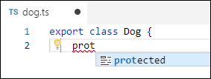
If VS Code knows about Phaser’s classes, constants, and such, it can help us write Phaser code:
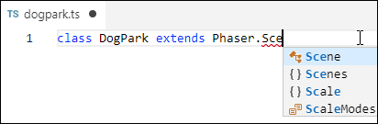
VS Code can do IntelliSense on our own code as well. For example, it can learn about our Dog class:
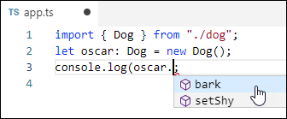
Let’s use linting, too. A linter is a program that checks code against a set of rules. The linter should run inside VSCode, so we can see its output as we work. For example:
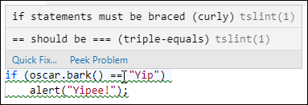
There’s a default linter rule set, but you can tweak it.
So, we want VS Code to have IntelliSense for all the things, and linting. One more VSCode bit: let’s make it easy to run our game from VS Code. Maybe right-click index.html, and run it on a local server.
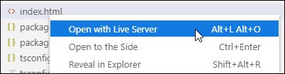
We can do that.

Source maps
We’re writing TypeScript, organized into many different files. When we’re debugging in a browser, we’d like to debug as if the browser was running our TypeScript. But, of course, the browser is running bundle.js, the compiled-and-smooshed-and-maybe-minified result of the build process. That makes debugging difficult, to say the least.
Fortunately, there are source map files. They have names like bundle.js.map. They tell browser debugging tools how the original source files map to the compiled code. You can work with what looks like the original files, setting breakpoints, look at variables, and so on.
Source maps should be part of our development environment.

Meeting the Goals
Now we know the three types of goals:
- Project organization: many files that refer to each other.
- Build process: many TypeScript files in — one JavaScript distributable out.
- Development environment: IntelliSense for everything. Linting. Run index.html on a local server. Source maps for debugging.

Meeting project organization goals
Let’s put all the files for the project into one folder. Its subfolders might be:
- src: our TypeScript source code will go here. The game’s entry point will be src/app.ts.
- lib: Phaser 3 and other libraries will go here.
- dist: the distribution ES5 file, bundle.js, will go here.
- assets: sprites, sound files, etc., will go here.
index.html will go into the project root.
That will meet the first goal:
- Project organization — Done
- Building the distributable — Up next
- Development environment
Onward!

Meeting build process goals
Remember the goals of the build process:
- Put all of our TS files in one end.
- Get one minified ES5 file (bundle.js) out of the other end (for production).
- Get one ES5 file (bundle.js) out of the other end (for development).
We’ll use Webpack to do the work. Webpack takes a bunch of files, and packs them together. It can also control TSC, the TypeScript compiler, so we don’t have to run it separately. That is, Webpack tells TSC to translate our TypeScript files into ES5 (and optionally make the source map files), before it packages them. The way we’re using it, Webpack is both a task runner (to control TSC for us), and a packer (to make the distributable). TypeScript files in — distributable out.
We’ll get to how to install Webpack later, after we’ve figured out all the pieces we need. Let’s focus on building a good mental model for now.
Apart from packing and minifying, we’ll also use Webpack to meet a goal for the development environment: making source maps.
We control Webpack with a file called webpack.config.js. Notice that this is a JS file, not a JSON file. Different tools are controlled by different types of files. Here’s a sample for this project:
The first thing Webpack has to do is compile our TS files to JS. It doesn’t know how to do that by itself. We tell Webpack to use the ts-loader plugin, which knows how to invoke TSC (the TypeScript compiler, remember) to compile TypeScript files. The test key gives a regular expression identifying the files to compile. In this case, every file with .ts at the end.
The output and filename keys tell Webpack where to put the packaged code. The devtool key says we want a source map.
So far, we have a config file for Webpack. However, remember that Webpack uses TSC. TSC needs its own config file, tsconfig.json. This works for me:
The target key means the compilation target is ES5. How to do the module import/export in ES5? Using CommonJS. Generate source maps. Allow pure JS files. The next four are TypeScript options. The lib array includes some extra libraries, and helps Phaser IntelliSense work (more later).
With these two config files in place, we should be able to run Webpack, and end up with a distributable. Once everything is installed.
We’ve done the first two things now:
- Project organization — Done
- Building bundle.js, the code distributable — Done
- Development environment — Up next
Onward! Ad victorium!

Meeting development environment goals
For development, we want to:
- Get IntelliSense to work for TypeScript, Phaser, and our code.
- Linting.
- Easily run index.html on a local server.
- Make source maps available to the browser, for debugging.
The last one we’ve already done, by configuring TSC and Webpack.
VS Code has IntelliSense for TypeScript built in. No worries! It will also analyse our code for us, and add it to IntelliSense. More later.
Now for IntelliSense for Phaser. Most popular JS libraries have typing files, that IntelliSense can use to give its hints. Typing files have the extension .d.ts. The site DefinitelyTyped has a large collection. They’re easy to install from there.
At the time of writing, Phaser 3 has a typings file, but it has not been contributed to DefinitelyTyped. We’ll install it manually, later.
For linting, there’s TSLint, yet another dev tool. We need to install it, and hook it up to VS Code. No worries. There’s a VS Code extension for that. And an extension for opening a file in a local server, too.
That’s it! We now know what we want to achieve:
- Project organization. A nicely organized folder tree, with TypeScript code broken across files, linked by export and import.
- Building process. A smooshed ES5 package, minified for production.
- Development environment. VSCode with mondo IntelliSense, linting, source maps, and open-in-a-server.

Installing Everything (Finally!)
Time to hit the keyboard.
- Implementing project organization
- Implementing the build process
- Implementing the development environment

Implementing project organization
Let’s put all the files for the project into one folder, called doggame. Here are some ways to do it.

Windows
Start a command line shell. Win+R, type cmd, and press Enter.
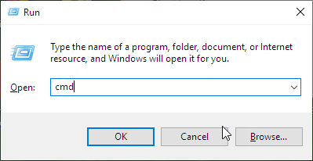
Mine looks like this, after I set some colors to make it easier on my eyes.
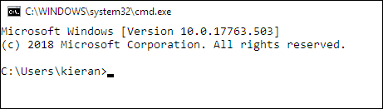
I put my projects on the D: drive, so I type d:<Enter>.
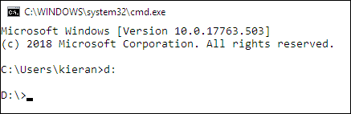
If you don’t have a D: drive, maybe type cd \ to switch to the root of the C:\ drive.
Create a folder for the project, and change into it:
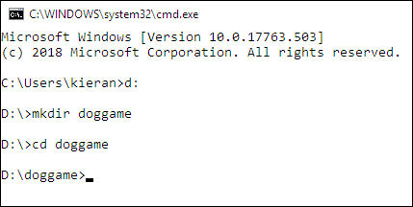
Next, make the folders for different parts of the project.
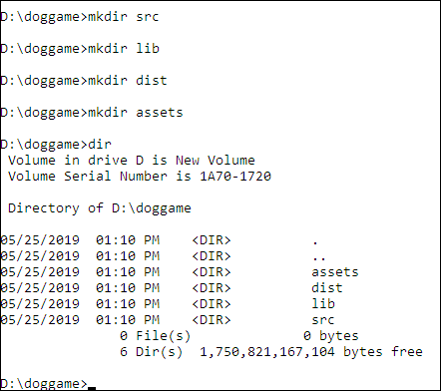

Linux
Pretty much the same thing.
cd ~
mkdir doggame
cd doggame
mkdir src
mkdir lib
mkdir dist
mkdir assets
Remember that the folders are:
- src: our TypeScript source code.
- lib: Phaser 3 and other libraries go here.
- dist: the distribution ES5 file, bundle.js, goes here.
- assets: sprites, sound files, etc.
index.html will go into the project root, that is, in D:\doggame , C:\doggame, ~/doggame, or whatever.
BTW, as far as I know right now, Windows and Linux are equally suited to Phaser 3 development.
While you’re here, download Phaser, and put it in the lib folder. What I did is go to the Phaser download page, right-click on min.js, and save:
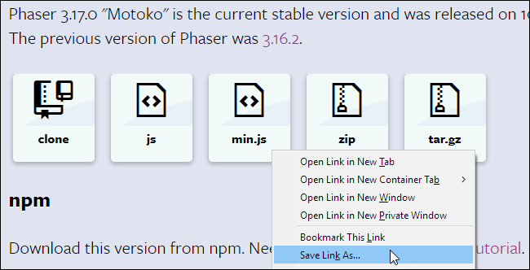
It’s also a good idea to grab the Phaser source code, from the zip file on the Phaser download page, or from GitHub. I’ve found myself referring to the source code sometimes, to figure something out.
Cool! What’s next?
- Install project organization stuff — Done
- Install build process stuff — Up next
- Install development environment stuff

Installing build process tools
We have a bunch of different dev tools to install. It’s easier if we use another tool to keep track of everything: NPM.

Install NPM
NPM is a dependency manager. It can install other software (like Webpack and TSC). NPM can track versions, and update software for you, without you having to download anything yourself.
NPM is part of the Node.js ecosystem. Node.js is a program that runs JavaScript in an OS, like any other language. For example, if you put PHP code in dog.php, you could tell your PHP interpreter to run it, like this:
php dog.php
If you put JS code in dog.js, you could tell Node to run it, like this:
node dog.js
With Node, JS is just another language you can work with, like C#, PHP, or Python. Of course, JS has a trick that the others don’t have: JS also runs in browsers.
The people who wrote tools to manage JS, like Webpack, know JS, of course. So they wrote their tools in JS. How to run JS? Node! That’s why Node appears so often in JS developer land. Even if you never write a Node app yourself, the tools you use need Node to run.
NPM is distributed with Node. Actually, NPM stands for “Node Package Manager.” Install node, and you get NPM.
Node.js installation procedures vary across OS. For Windows, download and run an installation file, usually with a .msi extension.
For Linux, something like:
sudo apt-get install node
Your command may vary, depending on your distro.
The Node installer will modify the system path, to make it easier to run NPM on the command line.
Now that NPM is installed, let’s set it up. We could just start using it, but it goes a little better with a configuration file. NPM will create one for you. Type:
npm init
NPM will ask you some questions. You can type answers, or keep hitting Enter to take the defaults. You’ll get the file package.json. What is package.json for? It’s where NPM tracks what it has downloaded.
You can edit package.json, if you want. I usually do. The default package.json file has this:
"main": "index.js",
That’s not the entry point I want, so I just delete the line.

Install TSC
Tell NPM to install TSC (the TypeScript compiler) by typing this:
npm install --save-dev typescript
Check out your project folder, and you can see what NPM did. First, it created a folder called node_modules. That’s where NPM puts stuff-it downloads for you. Inside that, you’ll see a folder called typescript. TSC itself is in typescript/lib/tsc.js. Yes, the TSC compiler is written in JS. It needs Node to run. That’s why it’s packaged as a Node module.
NPM also modified its configuration file, package.json. Remember that package.json is where NPM tracks what it has downloaded. It just grabbed TypeScript, so there should be an entry for that. Sure enough, open package.json , and you’ll see something like:
"devDependencies": {
"typescript": "^3.4.5"
}
It’s a dev dependency, because you typed --save-dev when you installed TSC.

Create a TSC config file
Put this in tsconfig.json:

Install Webpack
You’ll install two things here. First, ts-loader. Remember that we want Webpack to control TSC. ts-loader is a Webpack plugin that lets that happen. Type:
npm install --save-dev ts-loader
When that’s done:
npm install --save-dev webpack
This one takes a while. NPM downloads a shipload of stuff. Check in the node_modules folder.

Create a Webpack config file
Make the file webpack.config.js. Try this:

Let’s try it so far
Before we get to VS Code, let’s try what we have so far. Let’s make an app with some code you saw earlier.
Make index.html in your project root, with this in it:
Now make src/dog.ts, with this:
One more file, the app entry point, src/app.ts:
import { Dog } from "./dog";
let oscar: Dog = new Dog();
console.log(oscar.bark());
Now for the big test. Run Webpack in the root of your project, where index.html is. If necessary, use the cd command to make that the current folder. For example, if the current folder is src, type cd .. :
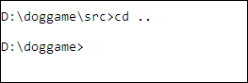
.. means “parent.”
Run this:
webpack --mode development
(The first time I ran this, it failed, because I used the file name app.js, instead of app.ts. The second time, it failed because I had named the TS config file tsconf.json, instead of tsconfig.json. So… things can go wrong.)
Webpack should run TSC, telling it to compile all of the TS files into JS files. You should get source maps as well. Then Webpack should smoosh the JS files together, into bundle.js. Because you asked for a dev build, bundle.js should not be minified.
You should see something like:
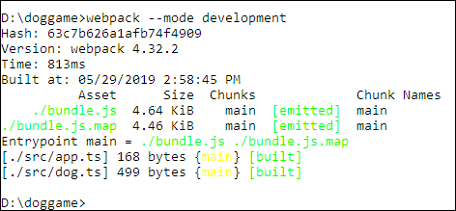
Webpack created bundle.js, combining code translated from app.ts, and dog.ts. Opening up bundle.js, I see:
It’s a smooshed file, but not minified. The code you see is where TSC sets up CommonJS to do export/import.
Open index.html in a browser, and see:
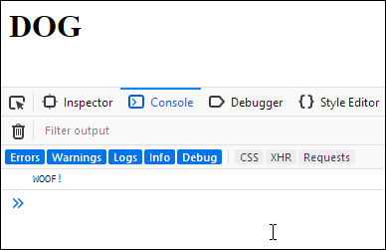
As expected!
Now try:
webpack --mode production
Check out bundle.js now:
!function(e){var t={};function r(n){
Minified! Hooray!
Now, how about the source map? Did that work? Looking in the dist folder, I see the file bundle.js.map. That looks promising. But will it work with the browser?
Here’s what I see in Chrome’s dev tools:
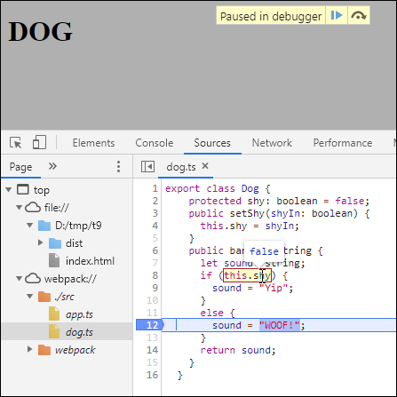
Hey! dog.ts shows up, even though the browser didn’t really load it (dog.ts was compiled into dog.js, and that was smooshed into bundle.js; bundle.js is what the browser actually loaded). I can set a breakpoint in the TypeScript code, and inspect a property of the Dog class.
One thing left to do.

Set up VS Code
Recall that we want VS Code, with:
- IntelliSense for all the things
- TypeScript linting
- Starting index.html in a server
- Source maps
The build process gives us the source maps. Time to do the rest.
Download VS Code for your platform, and install it. That will give you IntelliSense for TypeScript, and your own code. The latter happens automatically when you open your project folder in VS Code. You don’t need to do anything.
Download the typing file phaser.d.ts. If you cloned the Phaser repo, the file will be there too. Create a folder called types in your project folder. Copy phaser.d.ts there. Restart VS Code if it’s running. It should find the Phaser typing file itself.
At the command prompt in your project folder (that is, cd projectfolderpath), install the linter like this:
npm install --save-dev tslint
NPM will download TSLint into node_modules.
Like everything else, TSLint needs a config file, tslint.json. Create it like this:
node_modules\.bin\tslint --init
Now you need to tell VS Code about the linter. Install the TSLint extension:
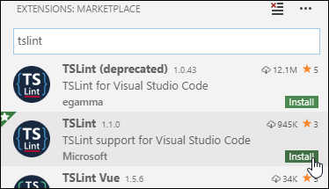
You might need to restart VS Code to get it working.
We want to be able to see a local file in a server, like this:
Install the Live Server extension.
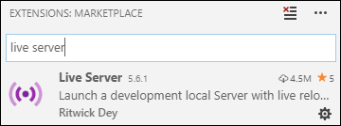

Dog Game
Let’s see how everything works, by making a game. What will the game be? Click on a background image, and a dog will jump there.

Teagan Mathieson
OK, not exciting, but it’s just an example.
Here are the files for the project:
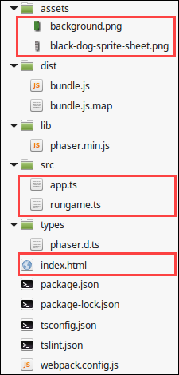
The files we make ourselves are highlighted. The other files we download, or they’re created by the tools we’ve installed.
We need one HTML and two TypeScript files. Here’s the code for index.html:
The script tags load in Phaser, and a file with minified, bundled JS translations of our TypeScript files. Webpack makes bundle.js.
Here’s the code for src/app.ts:
Notice const rather than var for declaring variables. If you use var, the linter will complain. Also note that all variables are typed. Nice!
The linter complains about two things in this program:
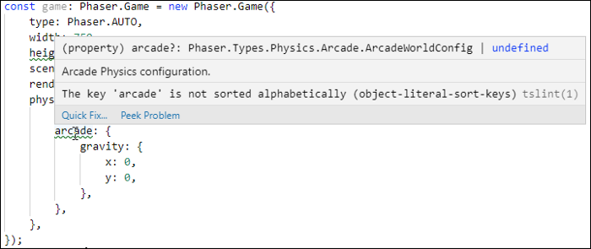
The linter says that keys should be sorted alphabetically. I’ve chosen to ignore this rule, since keeping semantically related keys together makes the code easier for humans to follow. See the Quick Fix at the bottom of the dialog? One of the options is to ignore the rule. VS Code will insert an annotation to that effect.
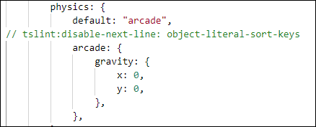
You can also disable the rule in the linter’s configuration file.
Here’s the last code file, src/rungame.ts:

Notice that all of the variables are typed. Also, no linter warnings in this file. After putting the art assets in place, and writing the code, I created the distributable like this:
webpack --mode production
You can run the result at https://doggame.kieranmathieson.com/. There’s a GitHub repo, too.

Done!
Sometimes, cutting and pasting commands from the Interweb is an exercise in frustration. You need to dig a little, and understand the tools you’re installing. Hopefully, this article will help you get ready to make great Phaser 3 games.
Thanks to Teagan Mathieson and Jeremy Sprigler for their help with this article.

Resources
VS Code. The free IDE for JavaScripters.
Webpack. Smoosh JS to reduce download time, and save users’ minutes.
TypeScript. Use this instead of writing plain JS. Your blood pressure will thank you.
Phaser. A JS game library. Good stuff.
Node.js. JS outside a web browser. NPM and other things need it.
TSLint. Nags you as you type your TypeScript. In a good way.
https://medium.com/@mathieso2000/setting-up-typescript-phaser-webpack-argh-2e059ac7dc1b

Quick start for Phaser 3 and TypeScript
Posted on October 8, 2022 by Michael


As I have time for small project experiments for myself, I decided to explore new developments with Phaser JS. In general, Phaser JS seems like a fun framework to enable novice game makers to build fun 2D games. The javascript language has become a popular choice since the language exists in every web browser.
What can you build with Phaser 3? Check out some examples here.
– Tetris
– Robowhale
– Fun Math Game
In this blog post, we walk through building a small space shooter game.
As you start Phaser JS development, many tutorials walk you through some process to setup a web server to serve html and javascript content. Unfortunately, plain JavaScript alone does not guide makers to create well formed code. In plain Javascript, coders need to create stuff in baby steps. In this process, you should test stuff at each step. If you use a tool like Visual Studio code, the tool provides awesome guidance and autocomplete for devs. It would be nice if tools could improve to help you find more code faults and common syntax mistakes.
The TypeScript language invented by Anders Hejlsberg comes to the rescue. The TypeScript language and related coding tools provides robust feedback to the coder while constructing code. The JavaScript language does not support ideas like class structures or interfaces. Classes enable makers to describe a consistent template for making objects, their related methods, and properties. In a similar way, interfaces enable coders to describe the properties and methods connected to an object, but does not define implementations of methods. It turns out these ideas provide an increased structure and guidance to professional developers to create large applications using JavaScript. When your tools help you find mistakes faster, you feel like you move faster. This provides great support for early stage devs. TypeScript borrows patterns and ideas from C#, another popular language for game developers and business developers.
I found a pretty nice starter kit that integrates TypeScript, a working web server, and Phaser 3 JS together. Here’s the general steps for setting up your Phaser 3 development environment.

Install Visual Studio Code
- This is my favorite code editor for web development.
- Install Visual Studio Code

Install NodeJs and NPM
- NodeJs enables coders to create JavaScript tools outside of the browser.
- npm – When you build software in modern times, tools that you build will depend upon other lego blocks. Those lego blocks may depend upon others. The node package manager makes it easy to install NodeJs tools and their related dependences.
- Use the following blog post to install NodeJs and NPM
- Installing NodeJs and NPM from kinsta.com

Install Yarn
- Install Yarn
- Yarn is a package manager that provides more project organization tools.

Download Phaser 3+TypeScript repository
- Navigate to https://github.com/geocine/phaser3-rollup-typescript/archive/refs/heads/master.zip
- Your web browser should download the phaser3-rollup-typescript starter kit.
- When the download is finished, unzip the master.zip file to a working folder.
On my environment, I have unziped the files to /home/michaelprosario/phaser3-rollup-typescript-master.

Finish the setup and run
cd /home/michaelprosario/phaser3-rollup-typescript-master
yarn install
yarn dev
At this point, you should see that the system has started a web server using vite. Open your browser to http://localhost:3000. You should see a bouncing Phaser logo.

Open up Visual Studio Code and start hacking
- Type CTRL+C in the terminal to stop the web server.
- In the terminal, type ‘code .’ to load Visual Studio Code for the current folder.
- Once Visual Studio Code loads, select “Terminal > New Terminal”
- In the terminal, execute ‘yarn dev’
- This will run your development web server and provide feedback to the coder on syntax errors every time a file gets saved.
- If everything compiles, the web server serves your game at http://localhost:3000

TypeScript Sample Code
Open src/scenes/Game.ts using Visual Studio Code. If you’ve done Java or some C#, the code style should feel more familiar.
import Phaser from 'phaser';

// Creates a scene called demo as a class
export default class Demo extends Phaser.Scene {
constructor() {
super('GameScene');
}

preload() {
// preload image asset into memory
this.load.image('logo', 'assets/phaser3-logo.png');
}

create() {
// add image to scene
const logo = this.add.image(400, 70, 'logo');
// bounce the logo using a tween
this.tweens.add({
targets: logo,
y: 350,
duration: 1500,
ease: 'Sine.inOut',
yoyo: true,
repeat: -1
});
}
}
http://inspiredtoeducate.net/inspiredtoeducate/quick-start-for-phaser-3-and-typescript/

